Strategic AI Blueprint: Agri Pride
Date: May 3, 2026

Section 1: Diagnostic Report
As Agri Pride scales its support for farmers in Uganda and Rwanda, our current AI implementation suffers from critical structural gaps that threaten both operational safety and user trust.

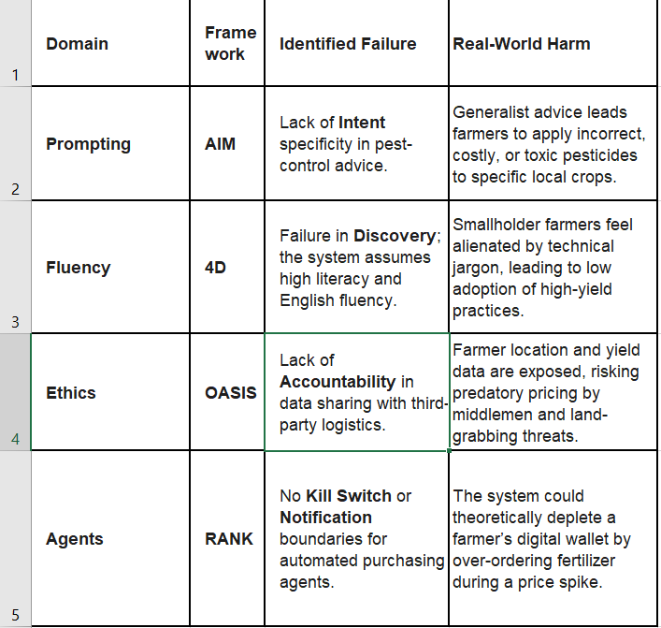

Section 2: Redesigned AI System

1. Prompting: The "Agri-Advisor" Redesign
Frameworks: AIM + MAP
- [A] Audience: A smallholder maize farmer in rural Uganda with basic English literacy.
- [I] Intent: Provide a clear, step by step organic mitigation strategy for Fall Armyworm.
- [M] Measure: The user should be able to identify the pest and list two immediate actions using local materials.
The Prompt:
"[M] Provide a structured response. [A] Use simple, encouraging language suitable for a community leader. [P] Focus on low-cost, organic methods.
Task: Explain how to use a neem leaf solution to treat maize. Break it down into:
1. Preparation,
2. Application time
3. Safety precautions."

2. Fluency: The "Field-Voice" Interaction
Framework: 4D (Dimension, Distance, Dialect, Discovery)
- Interaction: Voice-to-text diagnosis for crop disease.
- Temperature: 0.3 (To ensure high factual consistency and low hallucination).
- RAG Source: National Agricultural Research Organisation (NARO) Uganda - Crop Disease Database.
- Negative Prompt: "Do not suggest chemical fertilizers or expensive imported solutions. Avoid long paragraphs; use list format only."

3. Ethics: The "Secure-Soko" Protocol
Framework: TRACK + OASIS
- Decision: Sharing yield forecasts with regional distributors to secure better market prices for farmers.
- Action: We apply Oversight by anonymizing GPS coordinates to a 5km radius.
- Regulation: Compliant with the Uganda Data Protection and Privacy Act (2019), ensuring the "Right to Erasure" for all farmer profiles.

4. Agent Orchestration: The "Harvest Pride"
Framework: RANK + TRAIL
- Agent 1 (Scout): Analyzes satellite imagery for moisture stress.
- Agent 2 (Guardian): Manages irrigation triggers and budget.
- The Handoff:
  - RANK (Authority): Scout has "Read-Only" access. Guardian has "Execute" authority over water valves but cannot exceed 50 liters/day without human approval (Kill Switch).
  - TRAIL (Memory): Use Episodic Memory to track the last 48 hours of rainfall to prevent over-watering.

Section 3: Impact Projection (HORIZON Scan)
- Direct Users (Farmers): Within 5 years, we project a 40% increase in household income through precision-guided crop rotation and direct-to-market links.
- Surrounding Communities: The "multiplier effect" will stimulate local economies, as increased yields require more local labor for harvesting and transport, reducing urban migration.
- Non-Human Stakeholder (Land Health): By utilizing the Agri-Pride Scout Agent, we reduce chemical runoff into local watersheds by 25%, preserving soil microbiology and protecting the water quality of shared river systems.

Section 4: Reflection
This course has fundamentally shifted my view of AI from a "black box" of Western-centric data to a culturally resonant tool for African sovereignty.
A pivotal moment occurred during the Ethical Savannah module. I previously viewed "safety" as a technical bug-fix. However, realizing how a lack of OASIS Accountability could lead to digital neo-colonialism where African farmer data is harvested without benefit to the source changed my approach. I now understand that for AI to succeed in Africa, it must not only be "smart" but also "neighborly" respecting community boundaries, local dialects, and the specific ecological constraints of the land. AI is not just about code; it’s about the Agentic Pride working in harmony with the people it serves.

